What is polymorphism and why is it important?

It is the ability one child class has to modify the method if it parent class to provide a different outcome, and this can be a play to any child class to get different results in every class accordingly with it needs, as example in the code below we have a basic goal class:

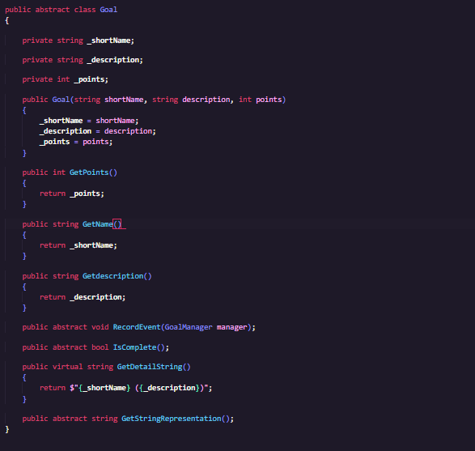

This class is an abstract class which allow it to have empty constructors allowed to be modified and used by it child classes. Then the abstract reserved word abstract or virtual can be use to determine if the method can be modify applying polymorphism. As shown in the image the method is complete does not have any outcome abut when is inherited by a child class that class can modify the logic of that method as example in the following images:

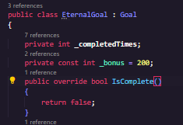 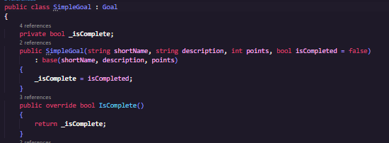

These two classes areconsidered child classes of goal, and the outcome from the _IsCompleted is different each time the method is call in each class, an eternal goal will never ends but a simple goals will end just if it is completed once. One of the benefits is that one method can be reused by child class making the code more reusable and easy to handled to escalate without redundace of methods.